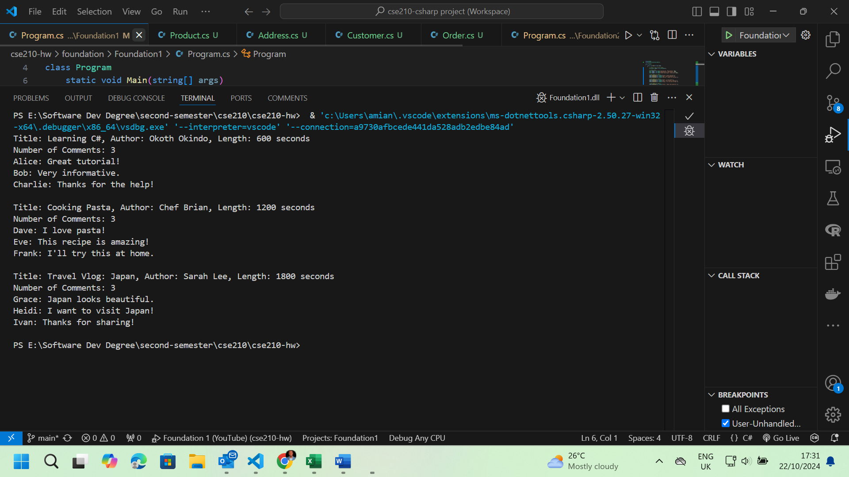

flowchart TD

A[Program] --> B[Video Class]

B --> C[AddComment()]

B --> D[GetNumberOfComments()]

B --> E[DisplayVideoInfo()]

F[Comment Class] --> G[DisplayComment()]

B --> F

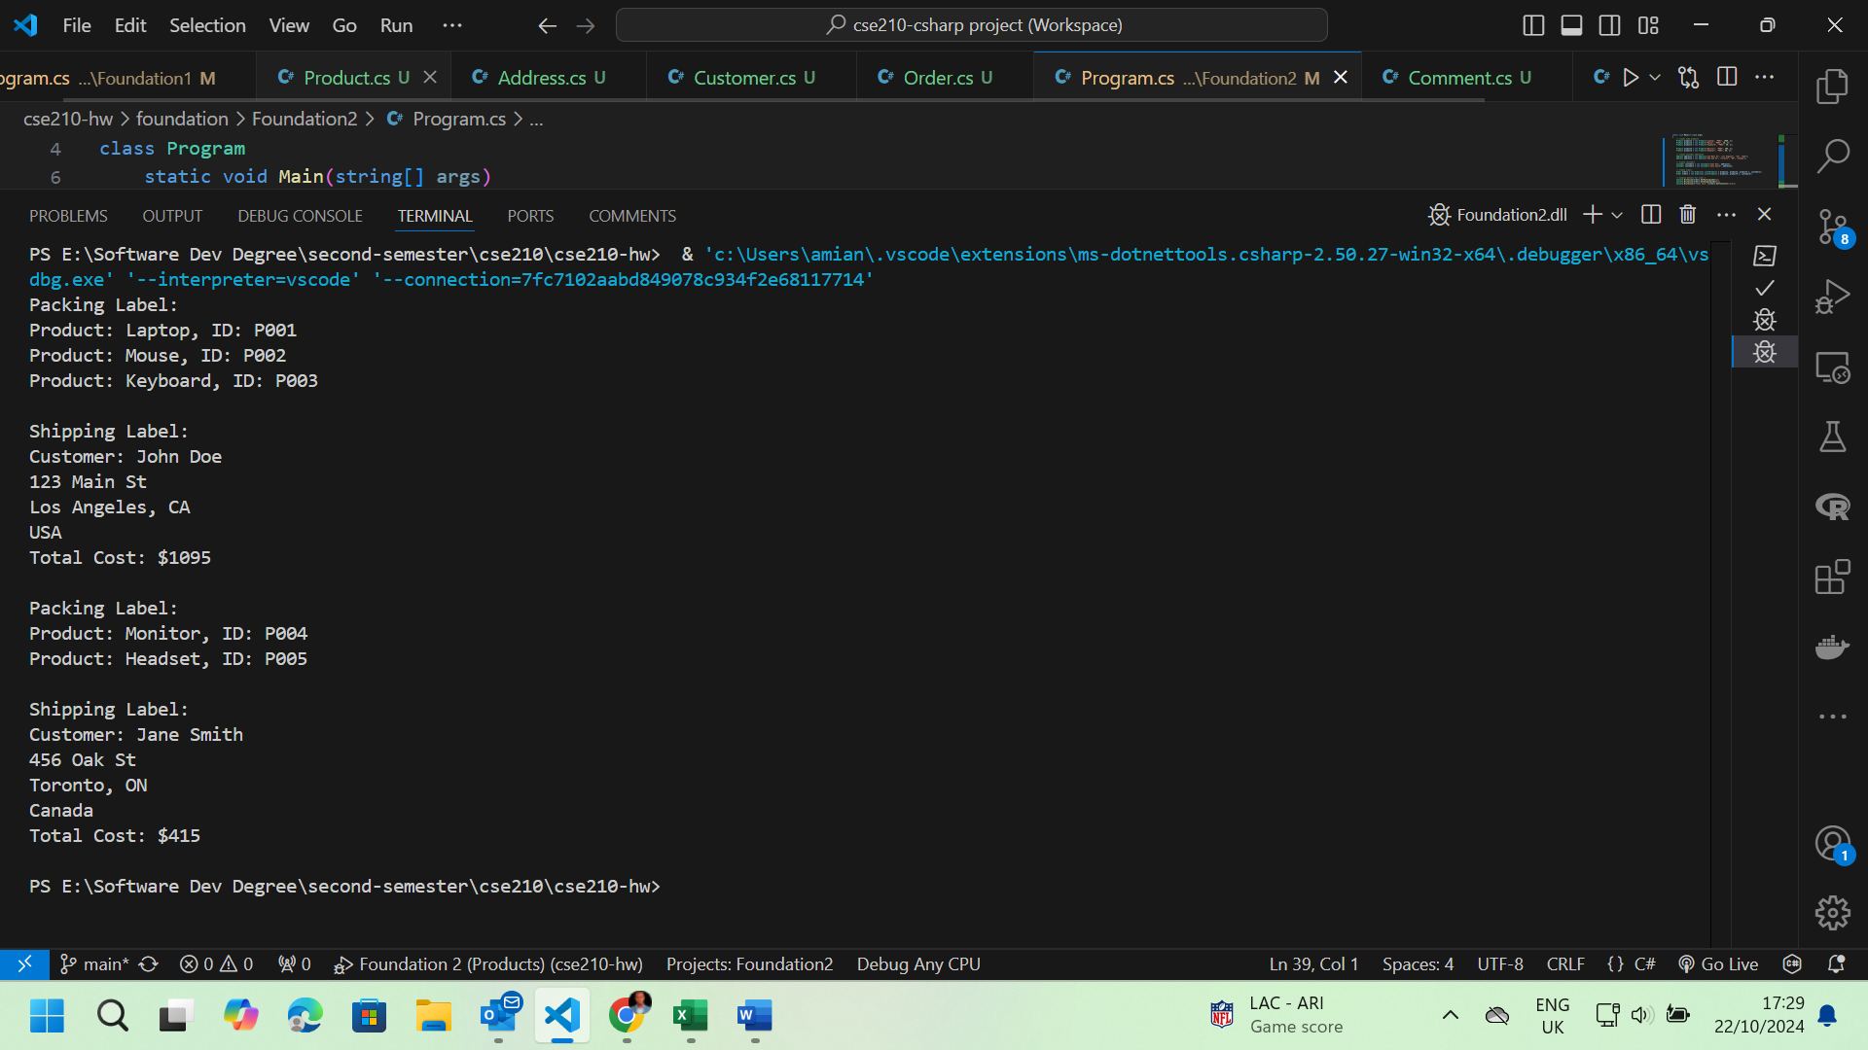

flowchart TD

A[Program] --> B[Order Class]

B --> C[GetTotalCost()]

B --> D[GetPackingLabel()]

B --> E[GetShippingLabel()]

F[Product Class] --> G[GetTotalCost()]

B --> F

H[Customer Class] --> I[IsInUSA()]

H --> J[GetShippingLabel()]

B --> H

K[Address Class] --> L[IsInUSA()]

K --> M[GetFullAddress()]

H --> K